Nursing at St George’s!
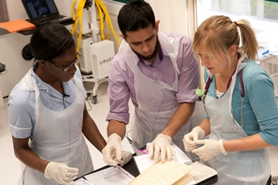
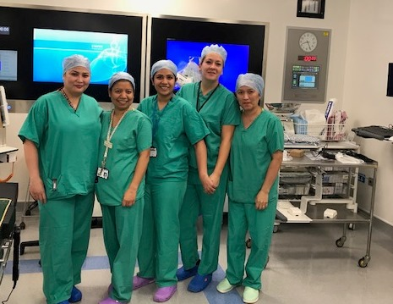
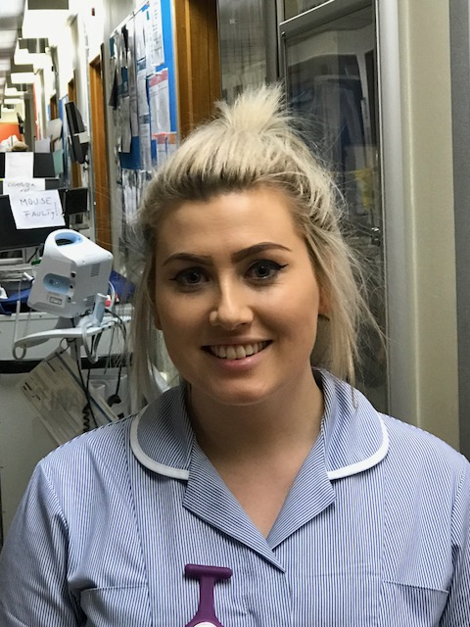
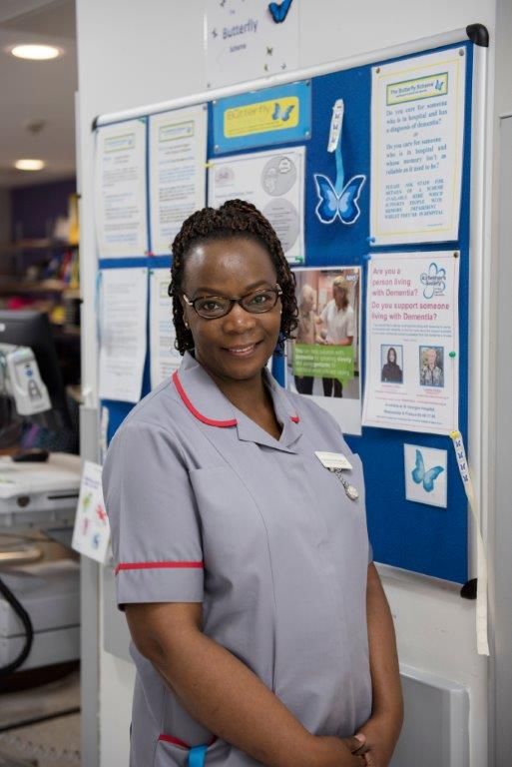
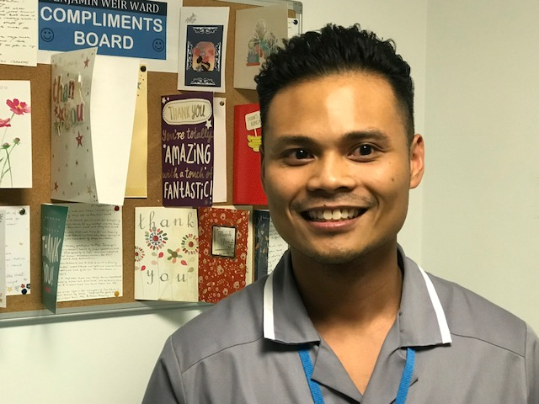
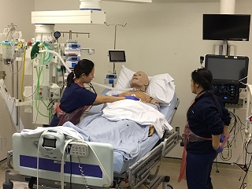

The St George’s Nursing Journey

One of London’s busiest Acute Trusts
- 9,000 staff including 3,500 + nurses
- 50 + wards
- World-leading services include Neurosciences and Cardiology
- Major Trauma Centre, Hyper Acute Stroke Unit, Ambulatory Care
- 2 hospital sites – St George’s in Tooting and Queen Mary’s Community Hospital in Roehampton
- Every year….
- 600,000 + outpatient appointments
- 150,000 emergency admissions
- 50,000 inpatient and day case operations.
- Unique nursing opportunities
- Adults, Paediatrics (including Paediatric A & E); inpatients & outpatients
- 40 + different specialties.

The right place to develop your nursing career
- Structured formal and informal education and training and career pathways
- Internal transfer scheme to support your career in different specialities
- Friendly, fun, supportive teams
- Broadest range of opportunities in a busy, large London Acute Trust – home of ‘24 Hours in A&E’
- Based in Tooting – one of ‘the world’s coolest neighbourhoods’
- Committed to our core values – kind, respectful, responsible and excellent.

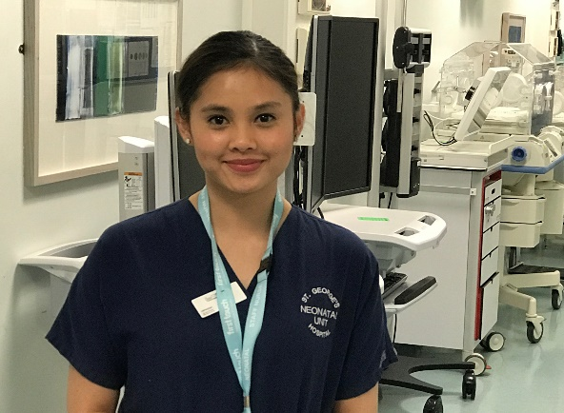
“It’s a great place to start and develop your career, with challenges and opportunities you wouldn’t get elsewhere. I am also learning lots on the post-graduate course, which lasts around nine months.
It’s part of getting the knowledge and experience to continue my career here and hopefully move up to a Band 6 role.”

Investing in education and development: supporting you

- Supernumerary support, initially as part of a robust local induction
- Preceptorship programme including a dedicated Preceptor
- Ongoing in-house courses and study days including leadership programmes; appraisal/ personal development review (PDR) training and practice supervisor and assessor training.
- Structured progression opportunities – Band 5 Newly Qualified Nurse Development Pathway
- Innovative Band 5 to 7 Development Pathway
- Simulator training - latest facilities onsite at St George’s Hospital
- Opportunities to apply for post-graduate courses
- Help and advice from dedicated Practice Educators
- Supportive teams and senior nurses helping you throughout your career.
- Nursing Competency Framework.

Life at St George’s – great staff benefits

- Starting Band 5 pay now from c£29,000
- All roles include ‘Inner London’ supplement (although we are South West London)
- Flexible working
- Generous annual leave: 0-5 years’ service - 35 days inclusive of public holidays
- Excellent NHS pension scheme
- Interest free travel loan; subsidised Cycle to Work scheme
- Accommodation: properties and support finding a place
- Facilities on site include restaurants and cafes
- Sports and leisure facilities and discounts
- Childcare; counselling; health and well-being programme.

Nursing Specialities – we have everything for you!

At St George’s, you can be guaranteed a wide variety of nursing specialities and opportunities. The only 2 specialities we do not provide are radiotherapy and burns.

Surgery: We have many different surgical wards including maxillofacial/ENT; plastics and gynaecology; urology; upper GI and colorectal; breast; trauma and orthopaedics and a surgical assessment unit.

Acute and Specialist Medicine: We offer a variety of wards to gain level 1 and 2 medical nursing experience. From our acute medical assessment units to more specialised ward areas including respiratory, diabetes, gastrology and hepatology and infectious diseases.

Endoscopy across 3 sites; St George’s site – tertiary referral centre as well as national training centre; Queen Mary’s site (community site) is expanding to 5 rooms and the Nelson, Wimbledon (community site).

Senior Health: dedicated to caring for elderly patients with complex needs/dementia and delirium.

Oncology/ Haematology: The Haematology/ Oncology department at St George’s provides high quality, patient centred diagnostics, care and treatments to the majority of southwest London areas as well as to some regional and national patients. We maintain an active cancer research portfolio and host the South London Cancer Research Network, which aims to improve the speed, quality and integration of research, ultimately resulting in improved patient care.
The Haematology/ Oncology department consists of three wards (haematology and transplant ward; oncology ward and one haematology/oncology ward); two day units (haematology and oncology); an apheresis unit; an ambulatory oncology care unit , Haemophilia Service, Sickle Cell Service, Macmillan support and Palliative Care Service.
Renal: St George’s also provides a complete range of inpatient and outpatient nephrology services for those with kidney conditions living in South West London. The unit is also the kidney transplantation centre for patients in South West London, Surrey and Sussex.

Neurosciences: We have a wide variety of neurosurgery, neuro-rehabilitation and neurosciences wards and departments. As the Hyper Acute Stroke service is situated within the tertiary neuroscience centre, it has access to state of the art equipment and a wealth of expertise. It also works closely with the Neuroradiology and Vascular Surgery departments to ensure patients receive rapid diagnosis and treatment.

Cardiac: Cardiology - the cardiac service is based across many wards and there is also a Coronary Care Unit and Heart Failure Unit providing care to a variety of cardiology patients; patients post MI, pre/post angioplasty, pre/post TAVI, endocarditis, out of hospital arrests, cardiomyopathy, life threatening arrhythmias and heart failure among many more complex conditions requiring interventions and revascularisation.
Cardiovascular & Thoracic Wards: Cardiac surgery includes: coronary artery bypass graft, aortic, mitral, tricuspid valve replacements, off-pump bypass surgery (beating heart surgery) and surgery of the aorta. Vascular surgery: lower limb amputation, carotid endarterectomy, limb bypass, aortic aneurysm repair, angiography, angioplasty and
clot-lysis. Thoracic Surgery: Bronchoscopies, video assisted thoroscopy (VATS), wedge resection, pleural biopsy, percutaneous biopsy, thoracotomy and mediastinoscopy.

Outpatients & Diagnostics: Busy departments across St George’s and Queen Mary’s Hospital in Roehampton, with specialities ranging from breast services, cardiology, dermatology, ENT, gastroenterology, gynaecology, neurology, plastics, rheumatology, trauma and orthopaedics, and urology to name a few. Diagnostic services also include radiology, interventional radiology and venous access departments.

Paediatrics: including a neonatal unit, Paediatric ICU and a Paediatric A and E. At St Georges we have a CQC outstanding rated Paediatric Department. This includes three inpatient paediatric wards, a busy day-care unit, a large PICU and an ambulatory care unit. We are a tertiary centre for a range of services, including Paediatric Surgery, Gastroenterology, Infectious Diseases and Neurosciences. We are a joint Primary Treatment Centre with The Royal Marsden Hospital caring for children with cancer.

Theatres and Recovery: We have over 29 different theatre and recovery areas (including a Day Surgery Unit) covering the majority of specialities.

Critical Care Areas
- Neuro Intensive Care
- Cardiothoracic Intensive Care
- General Intensive Care
- Theatres and Recovery
- Acute Dependency Unit on Richmond Acute Medical Unit
- Emergency Department (featured in Channel 4 ’24 hours in A and E’!)

Please visit our website for further information: https://www.stgeorges.nhs.uk/
All registered nurse and nursing associate jobs are advertised on NHS Jobs and we hold regular open days so that we can show you around and speak to you on an individual basis. We look forward to meeting you soon!

